

2nd October, 2014

OUR NEXT LEADFOOTS luncheon

The initial invites did go out very early this time, but the response has been good for the next gathering, so this is just a reminder for those that are still contemplating their reply (or have forgotten). You know we meet at:
THE BLUE GUM Hotel - 55 Pacific Highway, Waitara
The meeting time is the usual 12 for 12.30pm and you need to be there on Wednesday, 5th November. We have “The Terrace” booked for our congregation.

I mentioned before that Warren King will be joining us this time and he has agreed to talk to us about LOTUS and the Colin Chapman era. There were multiple business activities occurring at the time and Warren has firsthand knowledge of the goings-on. His talk will be supported by a selection of photos from the period - most of which have not been published before. It promises to be an interesting and enlightening afternoon.
For those not familiar with Warren (as an expat Aussie), he spent virtually all his working life at Lotus, from 1958 to 1993, with a number of financial responsibilities, which brought an involvement with a wide variety of activities. From Lotus Cars Chief Accountant at the end of the 60s, he covered JCL Marine making motor yachts, Lotus North America in California, the Delorean project, Lotus Engineering with Tony Rudd, Active Suspension in Florida, and finally GM Finances. Throughout he drove Lotus cars, starting with a Lotus Seven, and then every one of the Lotus models until the arrival of GM in 1986. Since 1993 he has been enjoying his Lotus Elan SE. He also regularly uses three older cars in every kind of motoring event - a 1955 Lagonda 3-litre saloon, a 1935 Lagonda Rapier roadster, and a 1937 Lagonda LG45 4.5 litre drop head coupe nearing the end of a lengthy restoration.
So, YES, I NEED TO KNOW IF YOU ARE COMING. Especially if you want to get in.
See you at lunch,

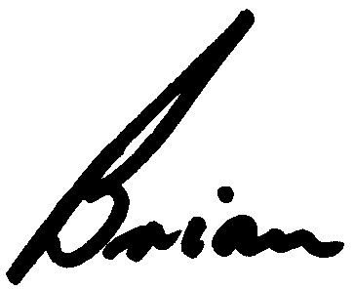

Brian Caldersmith

